Auto Scaling group
- Create an ec2 instance . Make it up and running
- Create image of instance
Actionimage and template create image

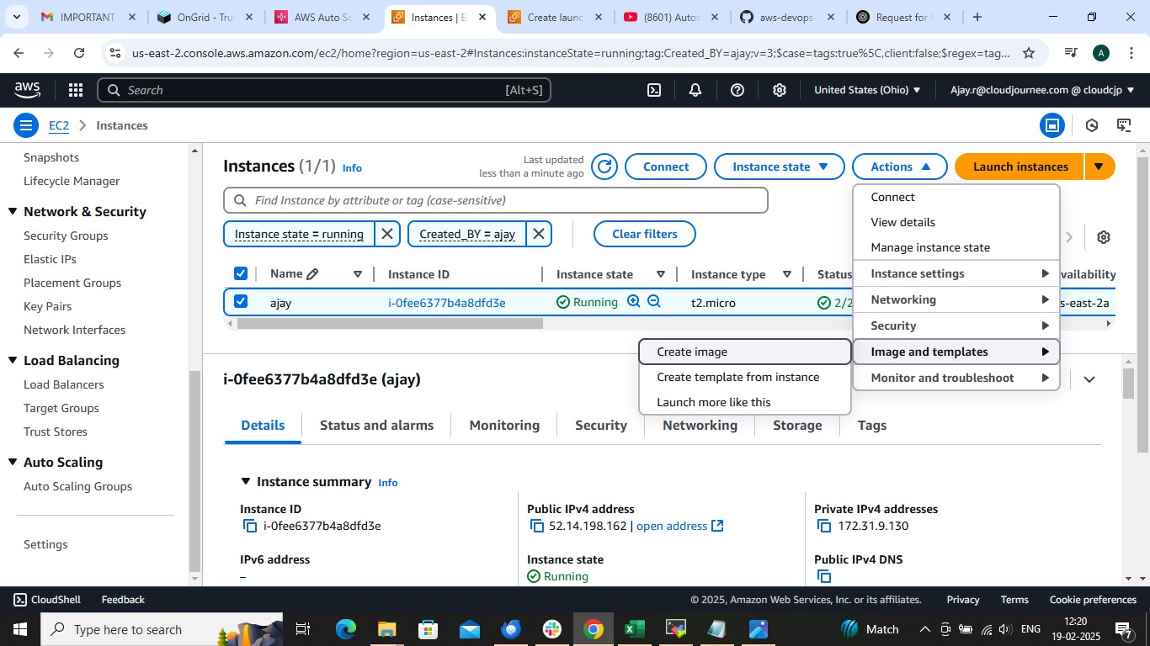

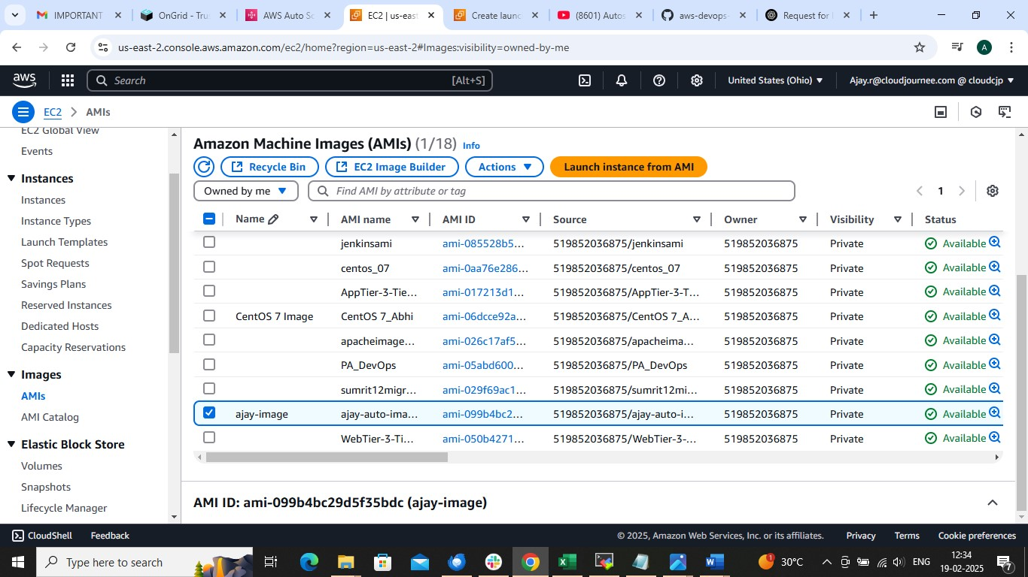

On Ec2 dashboard left side ASG Create ASG

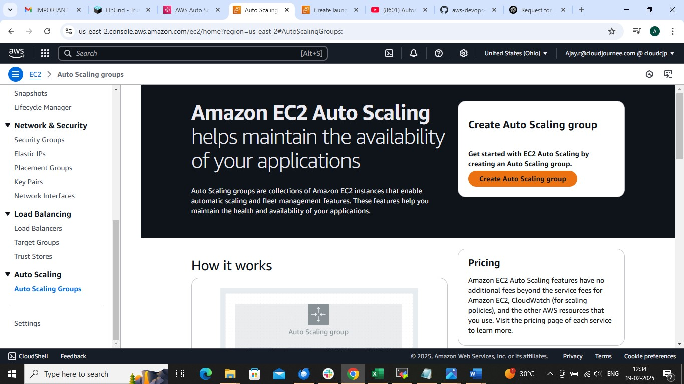

Create ASG name and = launch template
Create launch template name

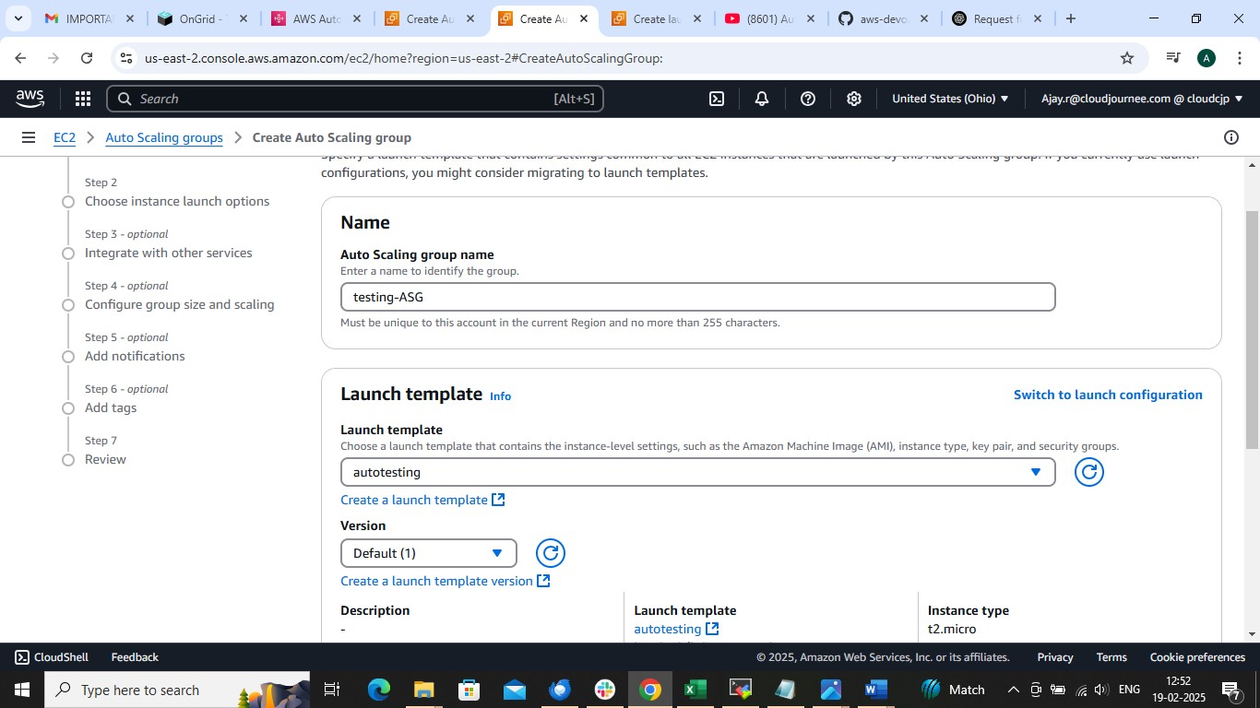

Choose Created image OR IF YOU HAVE NOT CREATED IMAGE THEN USE GIVEN AMI IMAGE FROM BELOW LIKE UBUNTU

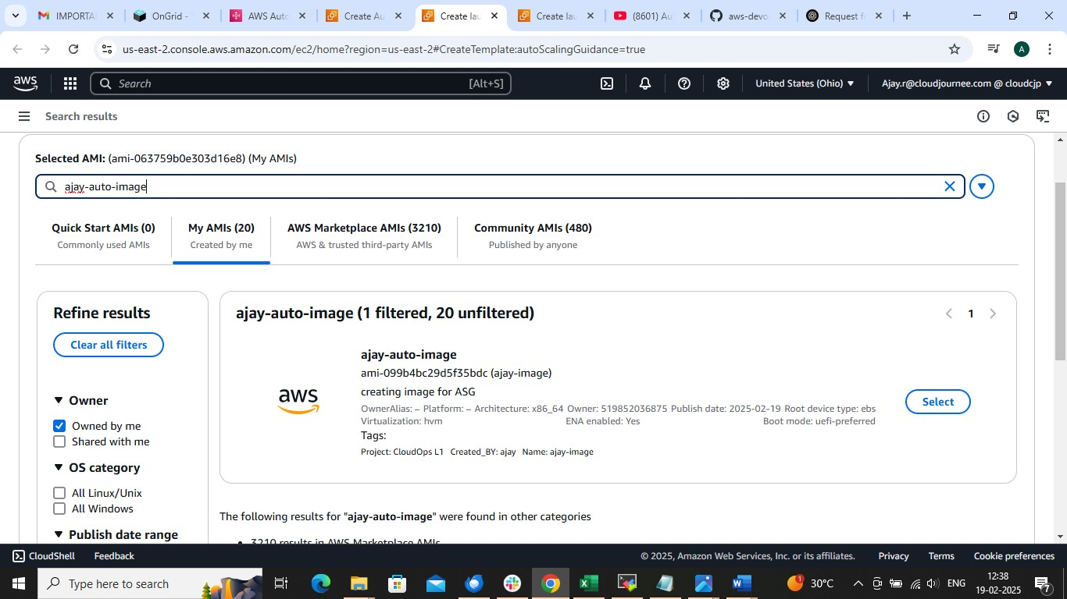

CHOOSE PROPERE INSTANCE TYPE
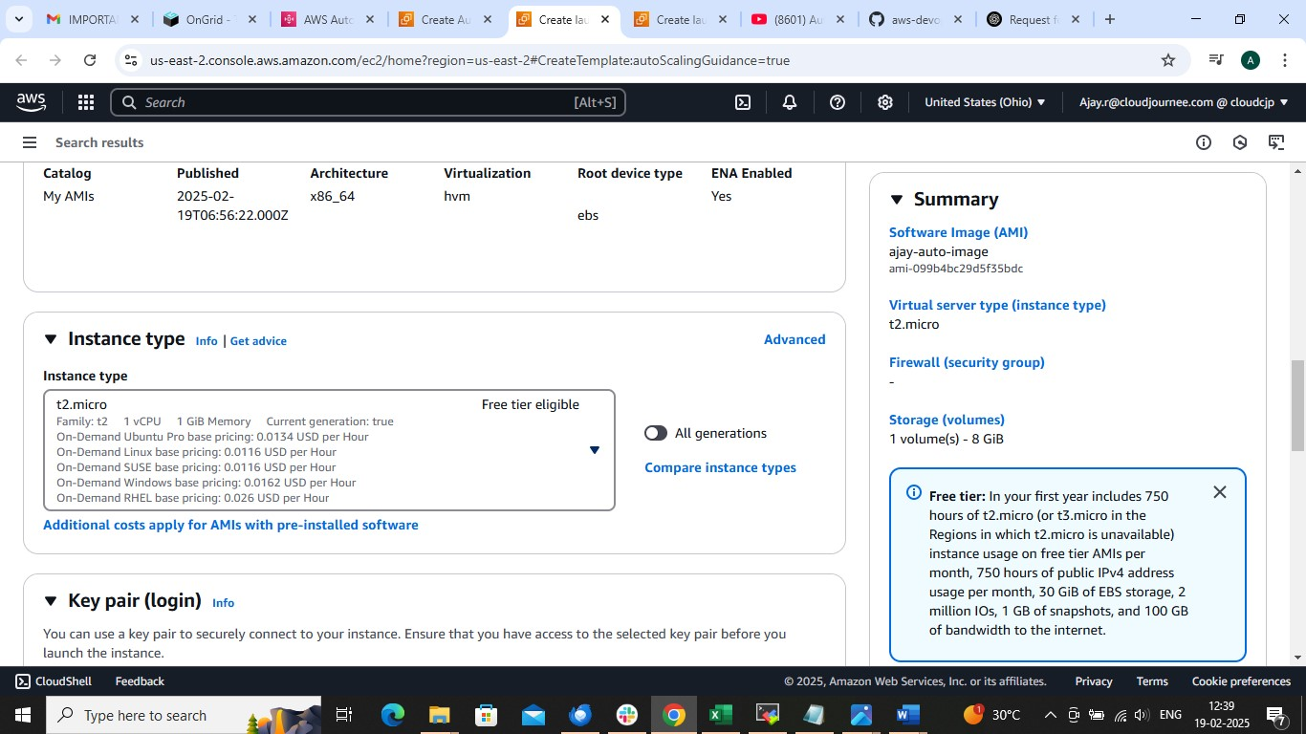
FOLLOW FOLLOWIMG STEPS AND LAUNCH TEMPLATE

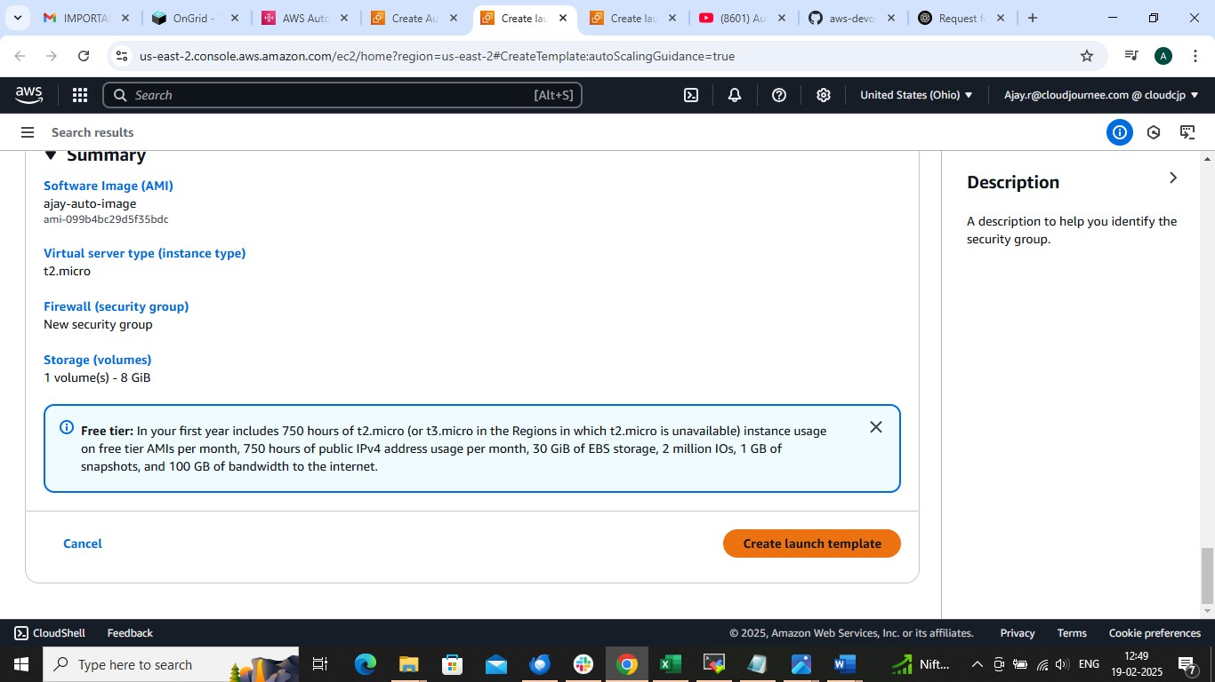

Go to ASG page and choose TEMPLATE

Choose VPC and subnet
CHOOSE 2 T0 3 SUBNETS
IF HAVE CREATED THEN CHOOSE OR CHOOSE DEFAULT ONE
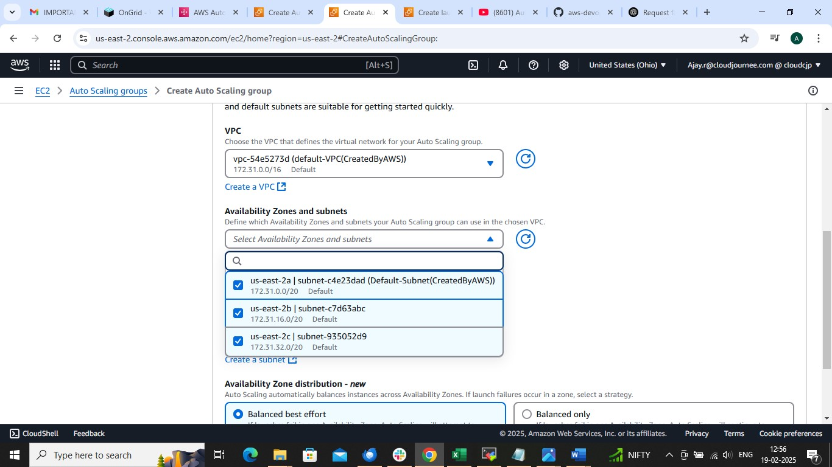

Check for ec2 health and put HEALTH GRACE PERIOD TO 60SEC
IT WILL AUTOMATICALLY REMOVE UNHEALTHY INSTANCE WITH HEALTHY ONE AG
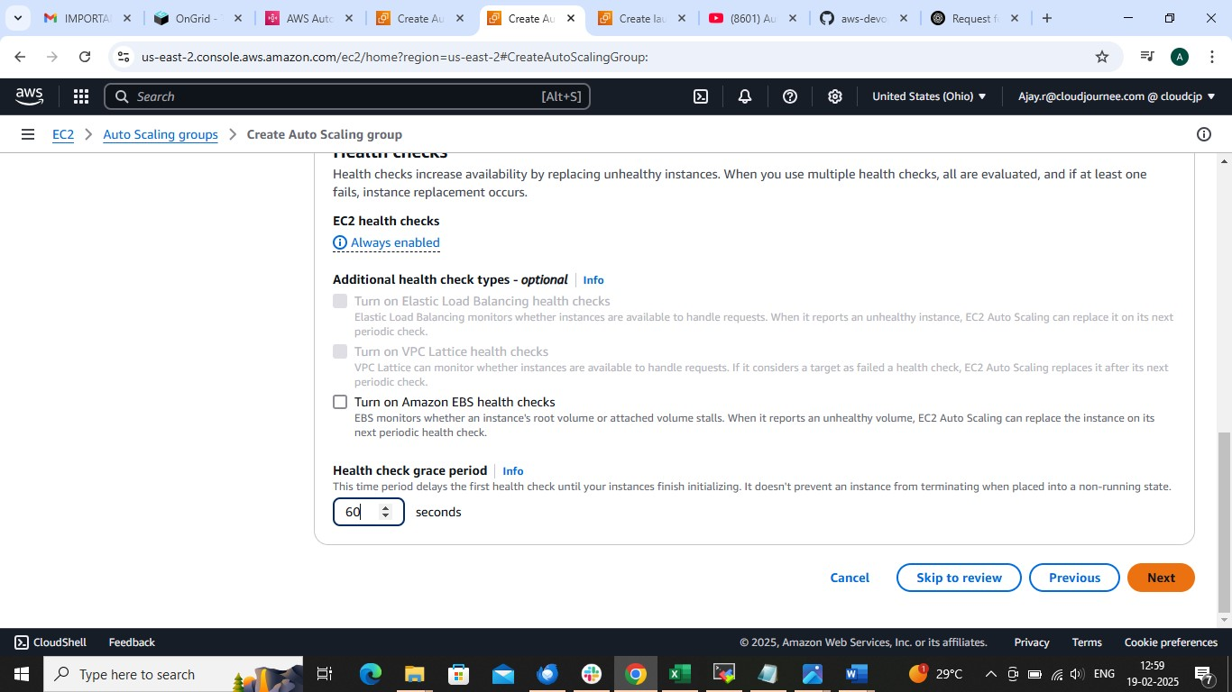

Configure max and min and desires number of instances
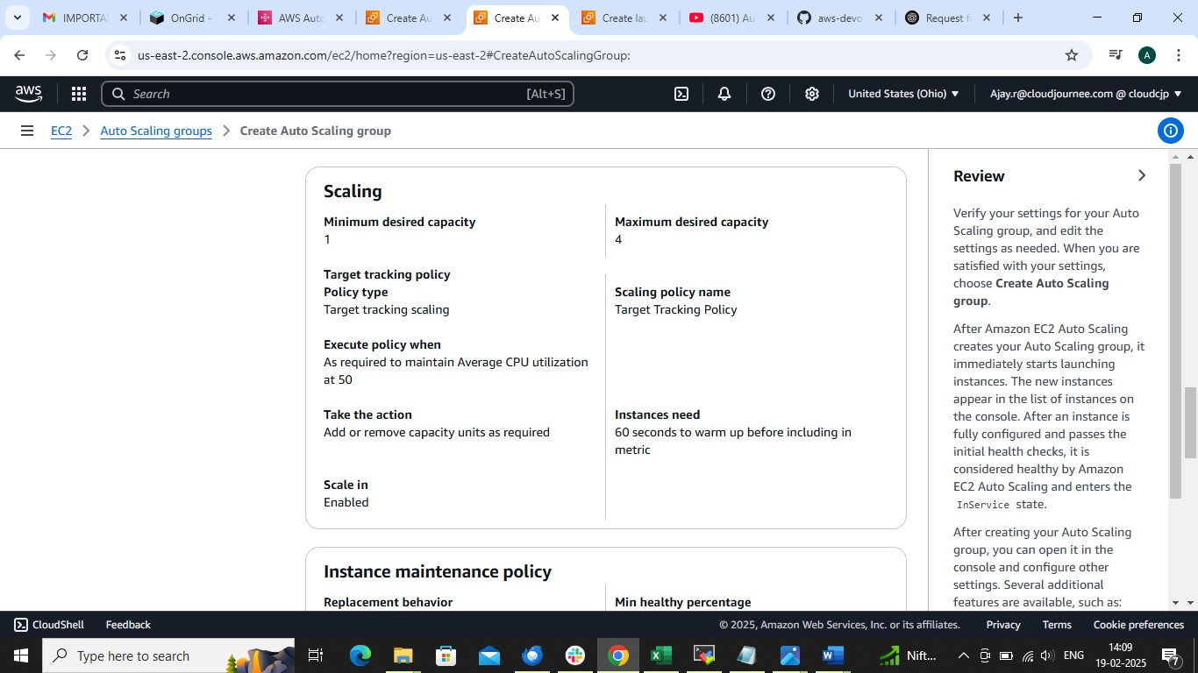

CHOOSE TARGET TRACKING SCALING AND SET CPU UTILIZATION 50
IT WILL AUTOMATICALLY INCREASE OR DECREASE INSTANCES BASED ON CUP UTILIZATION
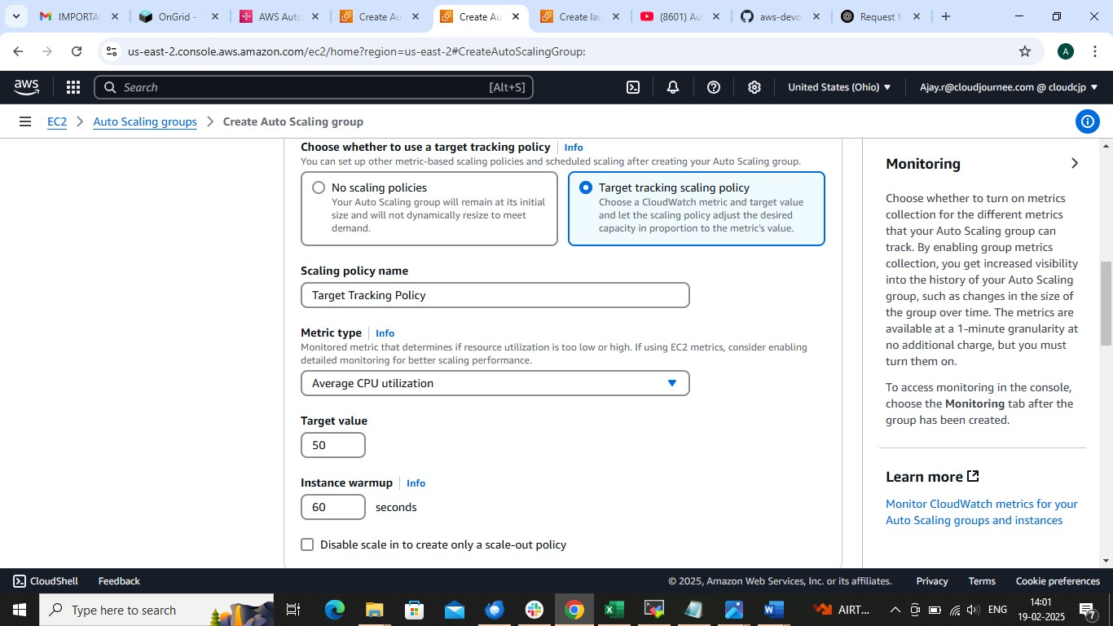

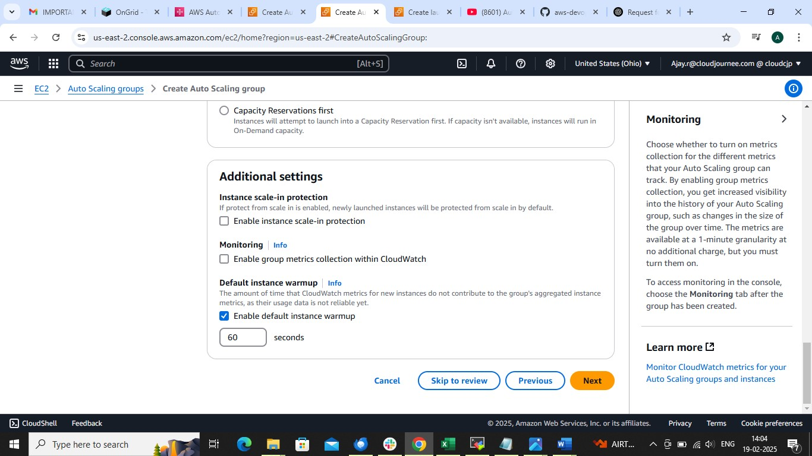

REVIEW AND CREATE
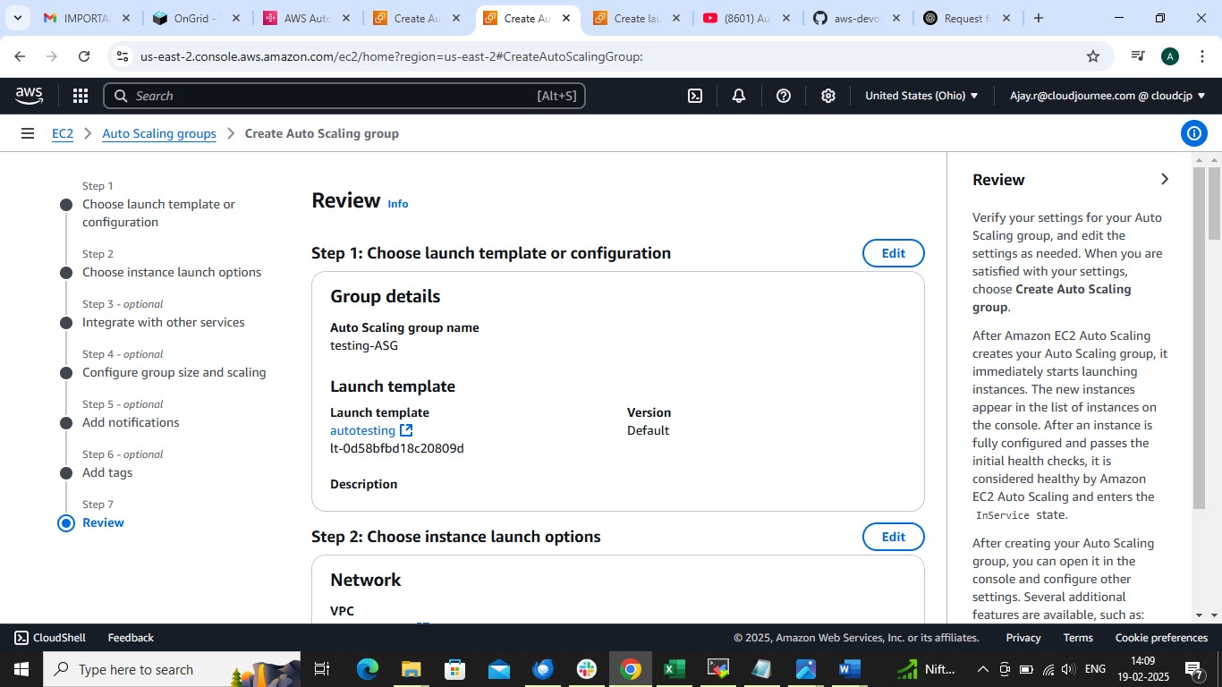

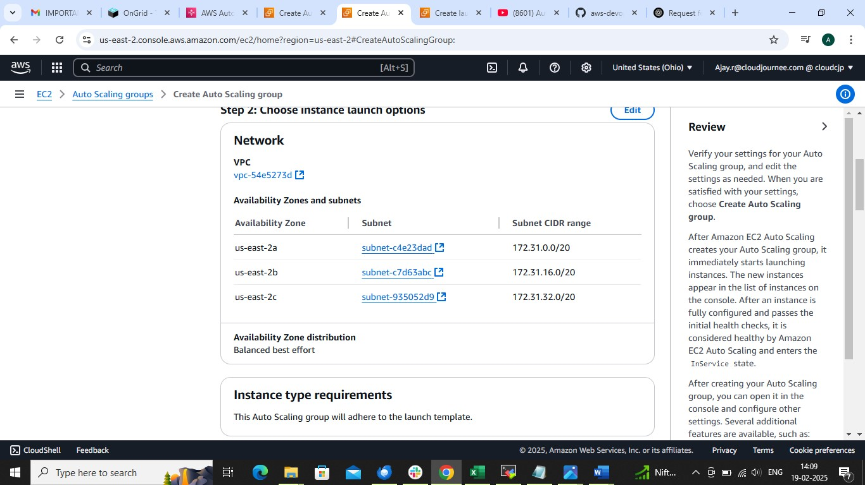

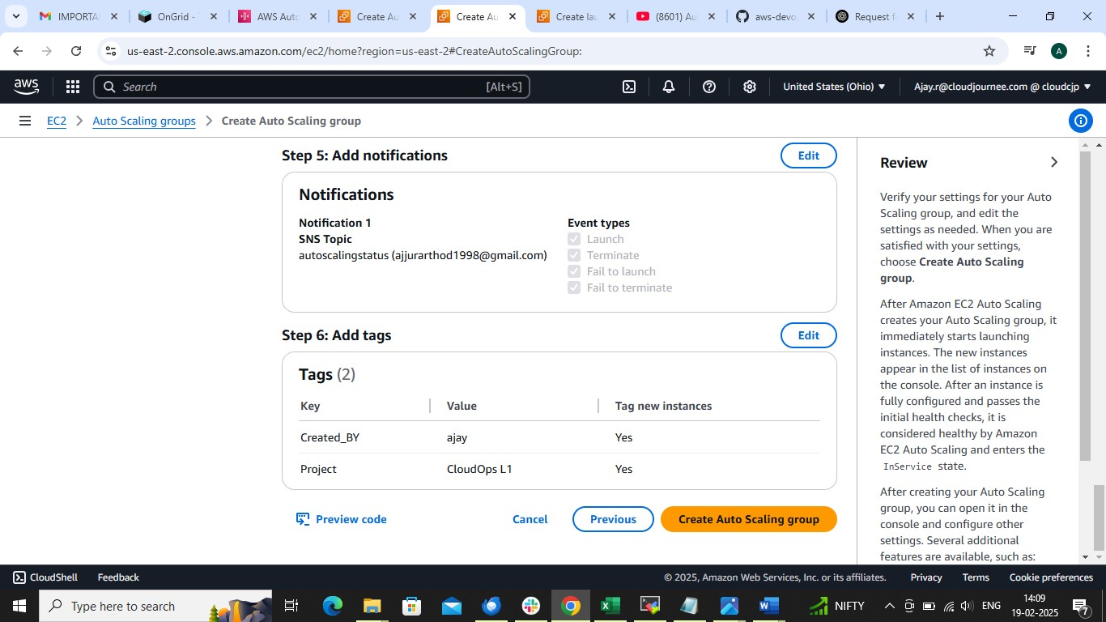

SEE THE RESULT
